# Project Report :

# Movie Searching Android App

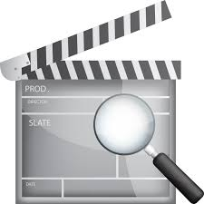

**Members:**

# *Rahul Agarwal 01*

***Sakshi Agarwal 02***

***Shrabani Aich Roy 03***

***Md Shabir Alam 04***

# Introduction : Aims And Objectives

The project aims at making an android app where an input is taken from the user on the search box so as to display related movie names in alphabetical order with its image ,related information like year of release and various ratings obtained.

Moreover, on further clicking, the full information is displayed regarding the movie be its director,producer,lead actors and actress, casts and even the achievements it won.

This application is developed using Android Software Development Kit using OMDb API to obtain the necessary movie information, all content and images.

# Required Technologies :

* *Android SDK(Android 9)*: The app is developed using Android Studio and SDK tools.
* *OMDB API* : OMDb or Open Movie Database,an openly maintained Database of movies and related content contributed by the users. Its API allows accessing data from this database for use in the project.
* *Programming Language:* JAVA is used to develop this android app.
* *Volley for Networking or sending JSON Object Request to API*: An HTTP library for networking. It helps to access network quickly. JSON Object Request fetches required movie information.

# Methodologies :

1*.Inception* – To build an application for a user to search movie name and necessaries details.

2*.Design* – User-friendly application so as to easily obtain information of the movie by few clicks away.Name of the movie is searched and all its related information displayed.

3.*Development* – It involves developing GUI for the user, database connectivity with JSON API to fetch the required information.

4.*Stabilization* – The API fetches data only a limited number of times per user.Further, an API key has to be acquired to keep gaining access to the OMDb.

5*.Deployment* – this is the final phase of implementation of the app. The app should be simple and easy to use while keeping its scalability high so as to cater all versions of android.

# Steps of System Design :

1. The application starts with a search box which is initially empty and ready for input.
2. As soon as user types in the required movie name, the API request are sent to the OMDB API, using the API key, which returns the result in form of a JSON Object. It identifies the token and provide necessary information.
3. Series of related movie name is displayed with supporting posters and information.
4. Next,Description of the movie, the short ‘Plot’ is extracted by using the omdbID from the Search Array and sending another API request.
5. These are displayed in different boxes forming multiple box view using Adapters. Recycler View refreshes each content again and again as user changes its movie preference.
6. OnBind() method binds the data with the recyclerview , and then show it to the user. XML layout is viewed as an output for the user.

**ScreenShots of the App sync and Build**

**1.Sync**

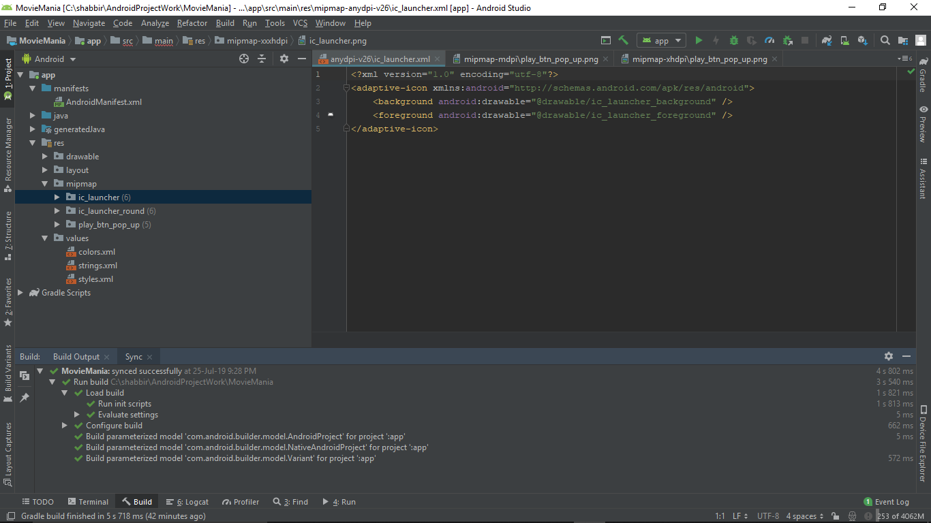

1. **Build Output**
2. 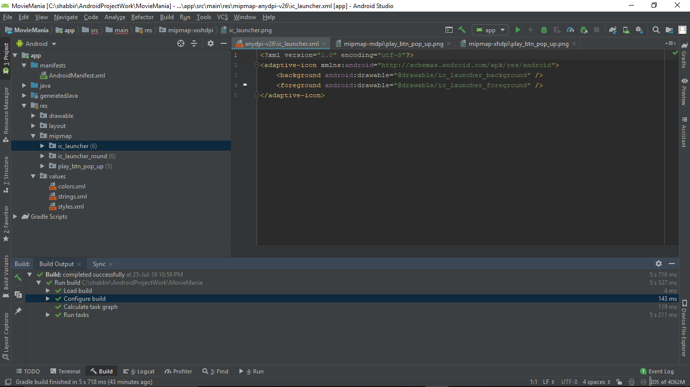

**Screenshots of the app:**

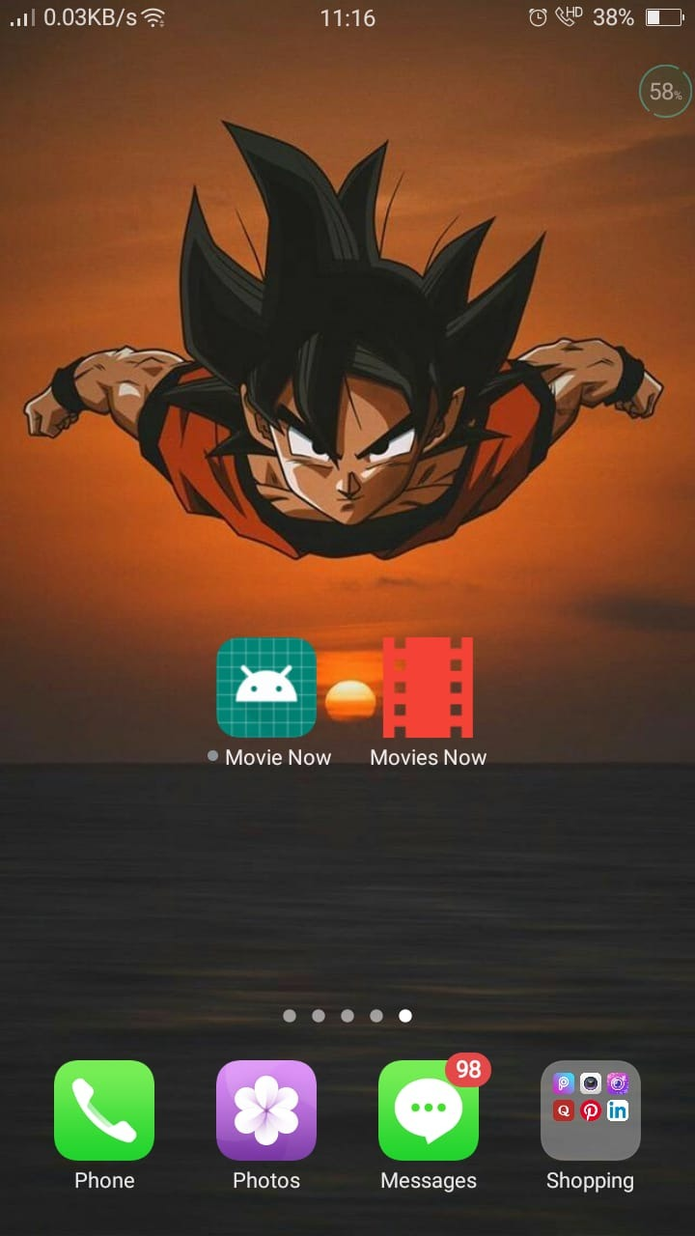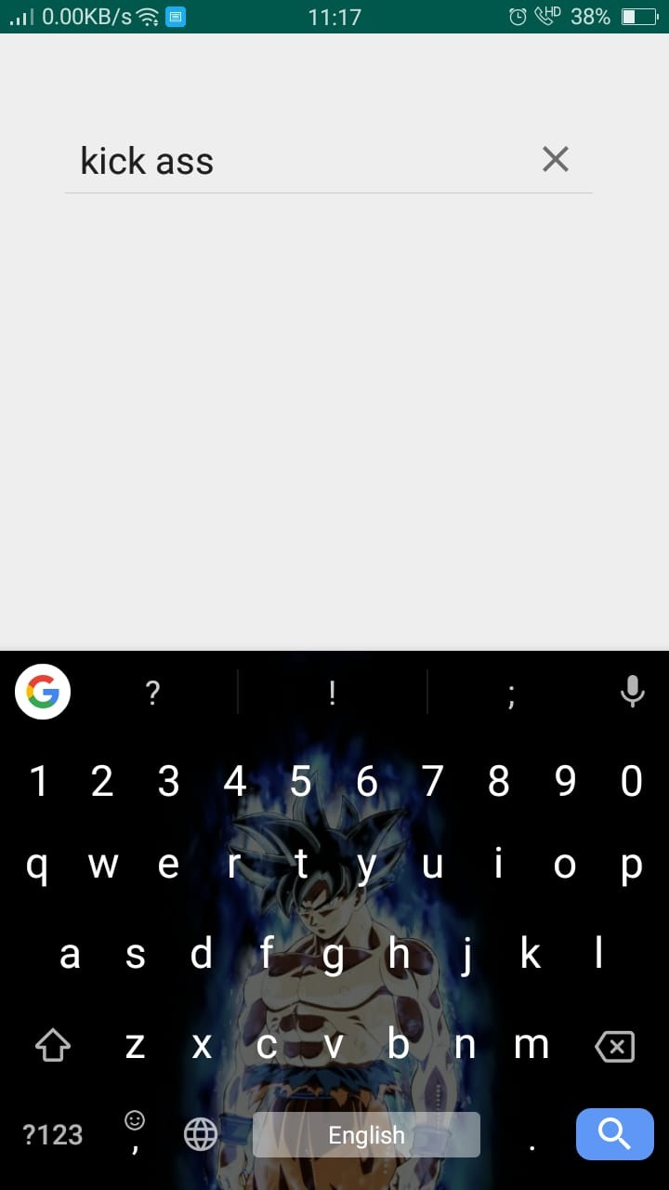

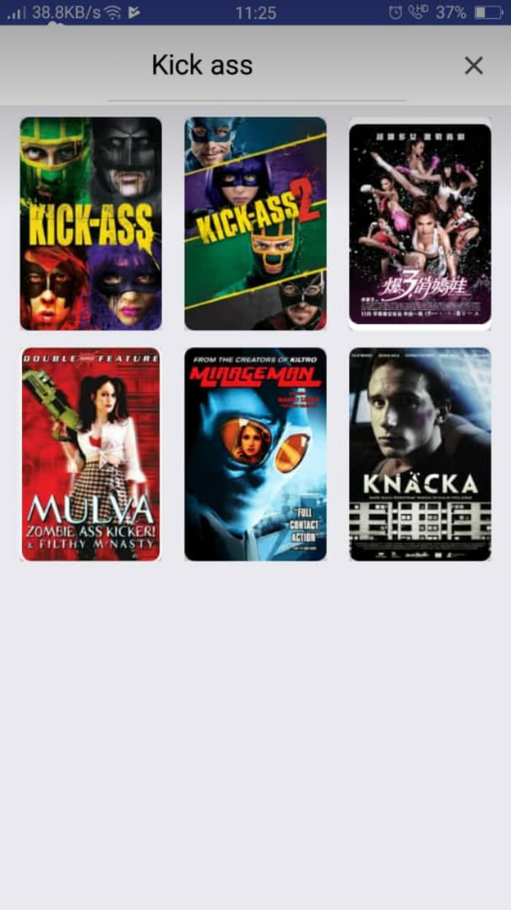

**Contributions of Team members :**

1. Rahul Agarwal(01) : Requirement Analysis and necessary Design of the app and, soft and hard copy of the project report.
2. Sakshi Agarwal(02):
3. Shrabani Aich Roy(03):
4. Md Shabir Alam(04) : Coding of the app using JAVA, XML and JSON API. Implementation of the app for the user.